Capstone Project — Part B
Consolidated Project Log, Weeks 1–7
Student Name(s): Ashraful Islam; Huzaifa Iqbal; Sonu; Dominic Kipchirchir
Student ID(s): 240135; 240220; 250001; 240401
Project Title: SEDAS — Social Engineering Defence and Awareness System
Supervisor: Dr Chandana Withana
Git Repository: github.com/ailinkon/MIS5320-SEDAS-CyberProjectB
Assessment: Assessment 3, Deliverable 3

Purpose of This Document
This consolidated log records the evolution of the SEDAS project across Weeks 1 to 7, from initial setup through minimum viable product to final refinement. It draws together the weekly logs submitted during the unit, together with the decisions taken, the challenges encountered, and the evidence produced at each stage.

Project Evolution at a Glance
Week | Phase | Principal activity | Key outcome
1 | Inception / Elaboration | Specification review, repository setup, detection model | Baseline model trained, F1 0.9865
2 | Construction | Benchmark identification and replication | Source paper [41] identified; SVC replicated at F1 99.16%
3 | Construction | Full method replication, URL service, frontend | All three paper methods replicated; three services running
4 | Construction | Contribution experiments | Four optimisation strategies tested; none improved on baseline
5 | Transition | Transformer comparison, literature expansion | DistilBERT preliminary; 16 new references added
6 | Transition | Artefact completion and test expansion | Training scoring engine implemented; suite expanded to 23 tests
7 | Transition | Documentation and consolidation | Technical manual, user guide, final report assembly
Table 1: Project progression by week.

Week 1 — Inception and Elaboration

Activities
- Reviewed the Part A specification and produced a Specification Review and MVP Refinement Memorandum, consolidating requirements into numbered form (FR-01 to FR-11, NFR-01 to NFR-08) and recording eight refinement decisions (R-01 to R-08).
- Established a private repository with a microservice folder structure, Python .gitignore, and a project log under version control.
- Acquired the phishing email corpus and trained a baseline TF-IDF and Logistic Regression classifier.
- Implemented the /classify REST endpoint with explainability output and auto-generated OpenAPI documentation.
- Created an automated test suite (TD-01 to TD-05) and a GitHub Actions continuous integration pipeline.

Decisions and justification
- Repository separation — Created a dedicated Part B repository for a clean implementation history, keeping Part A design artefacts separate.
- Private during assessment — Set the repository to private during the assessment period for academic-integrity reasons, to be made public after grade release.
- Eight refinements recorded — Descoped Ethereum smart contracts to a hash-chained registry (R-01), replaced live institutional integrations with mocked contracts (R-03), and re-baselined latency targets for CPU hardware (R-05).

Results
Metric | Result | Part A target | Status
F1 score | 0.9865 | ≥ 0.95 | Met
False-positive rate | 0.0144 | < 0.02 | Met
Classification latency | ≈ 11 ms | < 2,000 ms | Met
Table 2: Week 1 baseline model performance on 16,498 held-out emails.

Challenges
- PowerShell blocked virtual environment activation. Resolved with a least-privilege execution policy change scoped to the current user rather than system-wide.
- Generated artefacts (dataset, trained model) initially appeared in version control. Added to .gitignore before commit, keeping the repository to code and documentation only.

Weeks 2 and 3 — Benchmark Establishment and Service Expansion

Activities
- Traced the dataset to its source publication and adopted it as the project benchmark: Al-Subaiey et al. (2024), Computers and Electrical Engineering, 120:109625, numbered [41].
- Verified the dataset match exactly: the paper reports 42,891 phishing and 39,595 legitimate emails; the loaded corpus contains precisely those counts across 82,486 usable rows.
- Replicated all three of the paper's methods on the identical corpus and split, and added two team extensions.
- Implemented the URL verification service: heuristic risk analysis and a SHA-256 hash-chained append-only registry.
- Built a browser interface calling both services, verifying end-to-end integration.
- Formalised module ownership across the four team members in a RACI matrix and issued individual technical briefs.

Results
Method | Our F1 | Paper F1 | Delta | In paper?
SVC / LinearSVC | 99.16% | 99.0% | +0.16 | Yes — their best
Random Forest | 98.71% | 98.0% | +0.71 | Yes
Logistic Regression | 98.65% | — | — | No — extension
XGBoost | 97.56% | — | — | No — extension
Multinomial Naive Bayes | 97.47% | 98.0% | −0.53 | Yes
Table 3: Five-model benchmark comparison on the identical dataset.
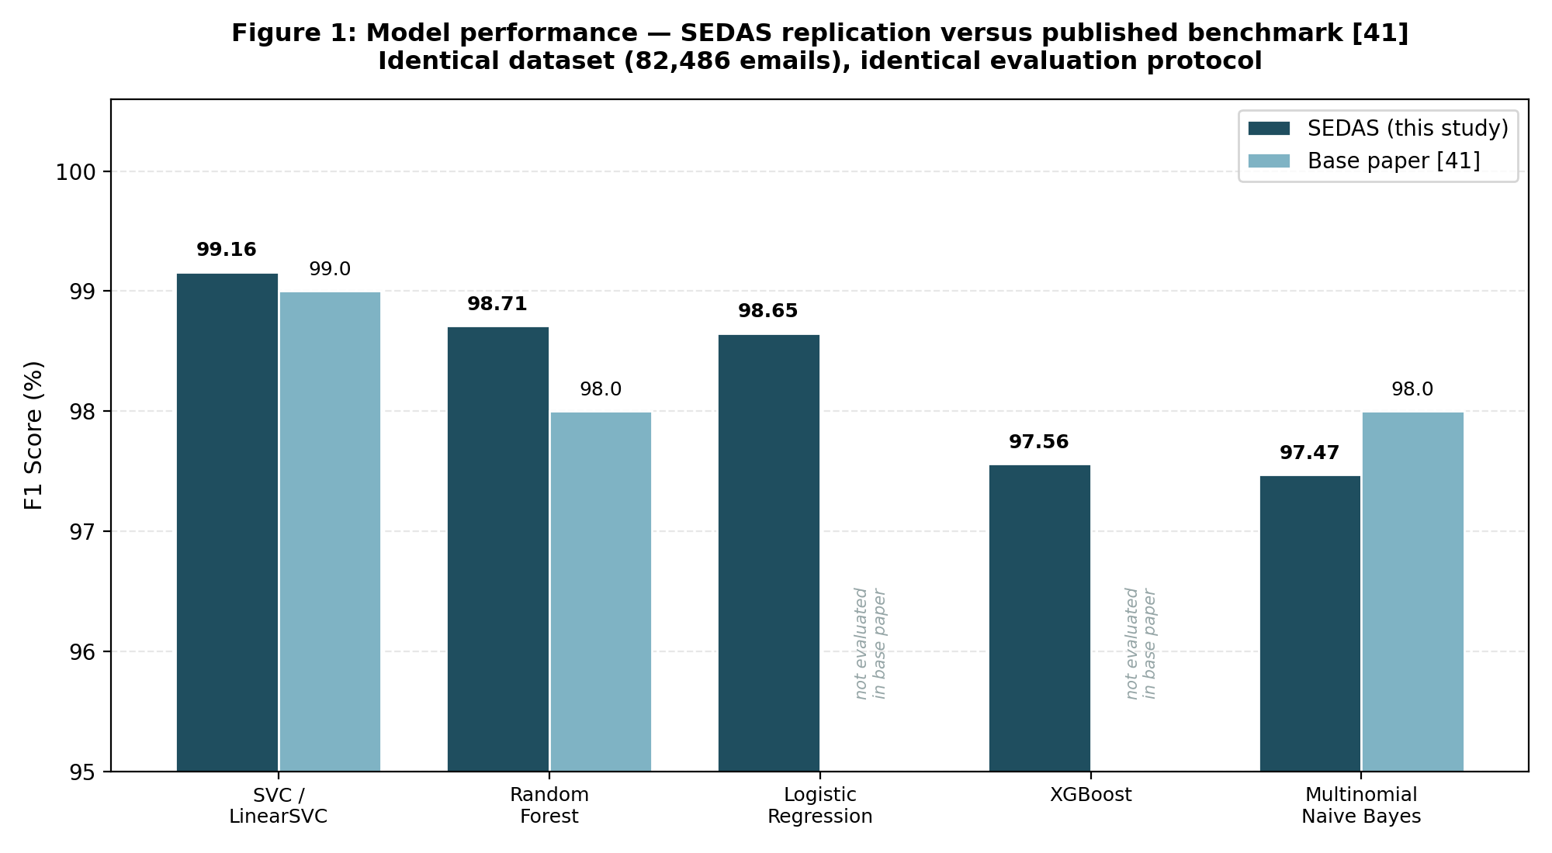
Figure 1: Model performance against the published benchmark.

Challenges
- Cross-origin requests from the local interface were blocked by the browser's same-origin policy. Resolved with CORS middleware, deliberately permissive for local demonstration and immediately recorded as a security finding requiring restriction before deployment.
- Early API testing produced HTTP 422 responses from malformed request bodies. Root cause identified from the validation detail; retained as evidence that server-side validation rejects malformed input with a descriptive error rather than failing.

Week 4 — Contribution Experiments

Supervisor directive
The supervisor stated that replicating the paper's methods and achieving similar or marginally better results does not by itself constitute a contribution, describing it as establishing a baseline only. The team was directed to explore techniques beyond those used in the paper, and warned to prepare a backup approach should results prove insignificant. It was further confirmed that the dataset's full feature set is already used by the paper, so no unused data existed to exploit and any contribution had to come from technique rather than data.

Activities
- Experiment 1 — Implemented text cleaning (URL normalisation, HTML stripping) with six hand-crafted signal features combined with TF-IDF vectors.
- Experiment 2 — Combined SVC, Random Forest and Logistic Regression with equal votes.
- Experiment 3 — Weighted the ensemble to give SVC three votes against one each for the weaker models.
- Experiment 4 — Evaluated seven values of the regularisation parameter C across the range 0.1 to 10.0.

Results
Experiment | F1 | Change from baseline
SVC baseline (replication) | 99.16% | Reference
Cleaned text + engineered features | 99.16% | +0.00 — no change
Equal-weight voting ensemble | 99.13% | −0.03 — slight degradation
Weighted voting ensemble | 99.17% | +0.01 — negligible
SVC tuning (C = 2.0) | 99.17% | +0.01 — negligible
Table 4: Outcomes of four optimisation strategies.
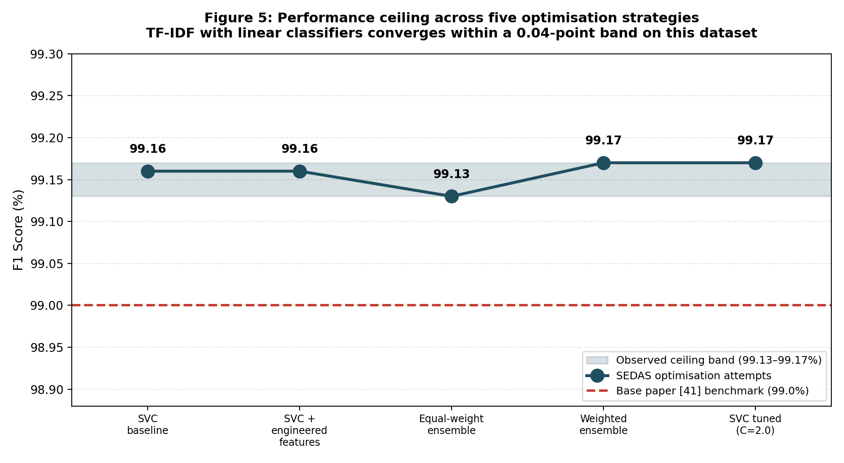
Figure 2: All five results converge within a 0.04-point band.

Interpretation
No strategy produced a meaningful improvement. Rather than presenting a 0.01-point difference as a gain, the team treated the convergence itself as the finding: TF-IDF combined with linear classifiers reaches a practical ceiling of approximately 99.15% on this dataset. Each failure was investigated and explained — engineered features proved redundant with signal TF-IDF already captures; equal-weight voting allowed two weaker models to outvote the strongest; the 3:1:1 weighting mathematically reduces to the strongest model acting alone; and tuning shifted performance by only 0.018 points from the default.

Week 5 — Transformer Comparison and Literature Expansion

Supervisor directive
The supervisor instructed that the final report follow the base paper's own section structure rather than the generic unit template, that Part A literature tables be carried across, that approximately fifteen recent references be added toward a total of 50 to 60, and that the Discussion section explain clearly why the results are significant — identified as the single most important element of the report.

Activities
- Fine-tuned DistilBERT on a stratified subsample of 6,000 emails, constrained by CPU-only hardware.
- Sourced sixteen additional recent references covering deep learning detection, transformer approaches, explainable AI, awareness training and blockchain-based URL verification.
- Restructured the report outline to follow the base paper's sequence and drafted literature review subsections.
- Produced results figures and data tables for the report.

Results
Metric | Value | Note
Accuracy | 97.92% | On 1,200 held-out emails
Precision | 97.77% | —
Recall | 98.24% | —
F1 score | 98.00% | Preliminary, subsample only
False-positive rate | 2.43% | Higher than all classical methods except XGBoost
Confusion matrix | TN=562 FP=14 FN=11 TP=613 | 25 total errors
Table 5: DistilBERT preliminary results.
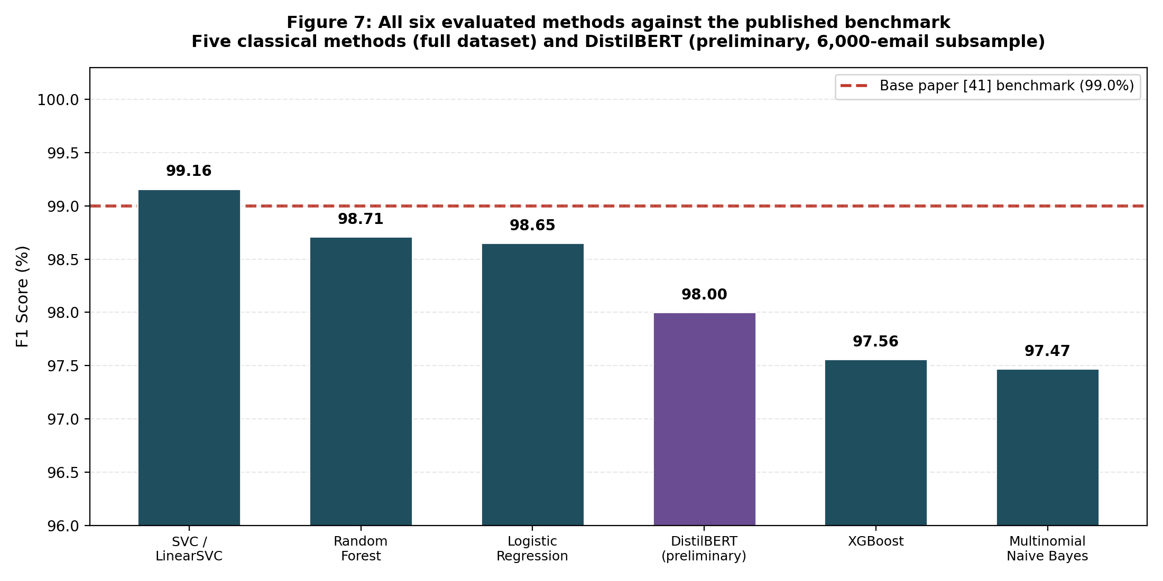
Figure 3: All six evaluated methods against the published benchmark.

Interpretation
The transformer was trained on 7.3% of the corpus against classical models trained on the full dataset, so the figures are indicative rather than directly comparable. Read correctly, the result is notable in the transformer's favour: it reached within 1.16 F1 points of the best classical model using a fraction of the data. Training loss declined steadily through the first epoch and rose slightly through the second, consistent with the onset of overfitting on a reduced sample — evidence that full-dataset fine-tuning is required for a definitive comparison.

Challenges
- The team was unable to evidence the base paper's journal name and Q1 ranking immediately when challenged during the consultation. Subsequently confirmed as Computers and Electrical Engineering (Elsevier, Q1), with ranking evidence prepared for future sessions.
- Verbal descriptions of the methodology given during the consultation did not fully align with the implemented code. Written documentation of the actual approach was distributed to all members to ensure consistency.

Week 6 — Artefact Completion and Test Expansion

Activities
- Implemented the four scoring engine functions in the training service: attempt scoring, exponentially weighted risk update, risk banding, and adaptive lesson selection. This completed the fourth system component, which had previously raised NotImplementedError on invocation.
- Verified the full training flow end to end: user registration, lesson delivery, quiz submission, risk update and next-lesson recommendation.
- Expanded the automated test suite from 8 tests to 23, adding TT-01 to TT-06 for the scoring engine and TS-01 to TS-06 for security and negative cases.
- Produced system architecture, data model and machine learning pipeline diagrams.

Test suite
Suite | Test IDs | Coverage | Requirements
Detection | TD-01..TD-05 | Health, detection, pass-through, explainability, latency | FR-01, FR-02, FR-09, NFR-03
URL verification | TU-01..TU-03 | Heuristics, report-then-blocked, chain integrity | FR-03, FR-04
Training | TT-01..TT-06 | Scoring, EWMA risk, banding, selection, fallback | FR-05, FR-06
Security | TS-01..TS-06 | Injection, malformed input, unknown resources, answer confidentiality, health, chain integrity | NFR-05
Table 6: Consolidated test suite — 23 tests, all passing.

Challenge and refinement
Expanding the test suite exposed a defect in the test harness itself. Both the URL verification and training services define a module named serve, so Python returned whichever module had been imported first, causing the URL verification tests to silently execute against the wrong service and return HTTP 404 responses. Diagnosed by observing that the security suite exercised the same endpoints successfully, because it loaded modules explicitly by file path. Resolved by applying the same explicit loading approach to the URL verification suite. This is recorded as an instance of testing revealing a genuine defect that was then corrected, rather than merely confirming existing behaviour.

Week 7 — Documentation and Consolidation

Activities
- Produced the Technical and Programmer Manual covering system overview, architecture, technology stack, data model, core modules, security controls and deployment instructions.
- Produced the User Guide, written for a non-technical audience, covering email checking, link verification, awareness training, everyday good practice, troubleshooting and a glossary.
- Consolidated the weekly logs into this Weeks 1 to 7 document.
- Assembled the final report following the base paper's structure, with all results, tables and figures embedded.

System state at completion
Component | Status
Detection service (port 8001) | Functional — classification with explainability, ≈ 7–11 ms
URL verification service (port 8002) | Functional — heuristics and hash-chained registry, ≈ 1.4–9.3 ms
Awareness training service (port 8003) | Functional — scoring engine, adaptive selection, progress tracking
Browser interface | Functional — integrated with detection and URL services
Test suite | 23 tests passing across four suites
Continuous integration | GitHub Actions running on every push and pull request
Table 7: System state at the end of Week 7.
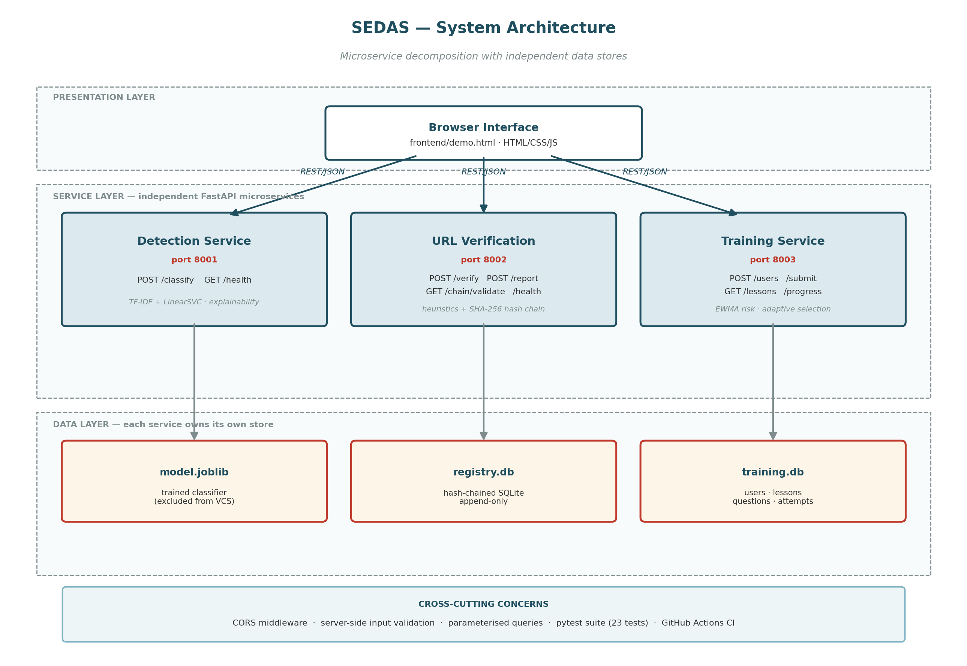
Figure 4: Final system architecture.

Overall Outcomes Against Objectives
Objective (Part A) | Target | Achieved | Status
Detection F1 | ≥ 0.95 | 0.9917 (tuned SVC) | Exceeded
False-positive rate | < 2% | 0.95% | Exceeded
Classification latency | < 2,000 ms | ≈ 7–11 ms | Exceeded
URL verification latency | < 2,000 ms | ≈ 1.4–9.3 ms | Exceeded
Registry tamper-evidence | Verifiable chain | Chain validation confirmed | Met
Adaptive training | Persona-based delivery | Implemented and verified | Met
Risky-click reduction | 30% (simulated) | Not measured | Deferred — requires user population
Table 8: Outcomes against the objectives defined in Part A.

Reflection

What the project achieved beyond its original objectives
- Benchmark validation — An independent replication of a Q1-published benchmark on the identical dataset, with full configuration disclosure supporting reproducibility.
- Method breadth — Six methods evaluated in total — three replicating the base paper, two classical extensions, and one transformer — where the original objectives specified a single detection approach.
- The ceiling finding — Systematic evidence across four optimisation strategies that TF-IDF with linear classifiers reaches a practical performance ceiling on this dataset, which has practical value for subsequent researchers.
- Operational metrics — False-positive rates, absolute error counts, full confusion matrices and measured latency, none of which the base paper reports.

Principal challenges and how they were addressed
- Establishing comparability — Addressed by tracing the dataset to its own source publication, giving an identical-corpus comparison rather than a topically similar one.
- Demonstrating contribution — Addressed by attempting improvement through four documented strategies, then reporting the negative result honestly with an explanation for each failure rather than overstating a marginal difference.
- Team capability — Addressed through a teach-in session, individual technical briefings, a machine learning guide written from first principles, and distribution of report sections so each member writes and can defend their own contribution.
- Hardware constraints — Addressed by scoping the transformer comparison as explicitly preliminary and documenting full-dataset fine-tuning as future work, rather than presenting a constrained result as definitive.

Known limitations at completion
- No authentication or role-based access control implemented at MVP scope.
- CORS configured permissively for local demonstration; requires restriction before deployment.
- The transformer comparison used 7.3% of the corpus and is not directly comparable to full-dataset results.
- Behavioural outcomes of the training module could not be measured against a real user population within project scope.
- Performance is established on public research corpora; live institutional traffic may differ due to domain shift.

Attachments and Evidence
- Meeting Minutes #1 to #5 (supervisor consultations and team meetings)
- Specification Review and MVP Refinement Memorandum
- Implementation Project Plan with RACI matrix
- Dataset and Benchmark Justification
- Technical and Programmer Manual
- User Guide
- Final Project Report
- Experiment scripts: compare_models.py, contribution_experiment.py, contribution_experiment_v2.py, distilbert_preliminary.py, generate_charts.py
- Test suites: test_detection.py, test_url_verify.py, test_training.py, test_security.py
- Twelve figures covering results, architecture, data model and pipeline
- Evidence screenshots in docs/evidence/

